Smart Refrigerator

Isabel Price, Kalino Ruiz, Matthew Manuel, Brent Marin, Caleb Mok

ME 195A Section 02

Instructor: Dr. Keith Yi

Technical Advisor: N/A

5/9/2025

Executive Summary
In California, the cost of electricity is continuously rising, leading to more households and individuals being unable to afford their electricity bills. Typical rate schedules for electricity costs have a peak period in which the price of electricity is increased due to the high demand during that time of the day. One method of reducing electricity cost in cooling systems is to shift the consumption of electricity from the peak time to off-peak through thermal mass.
Our product, the Smart Refrigerator, is a mini refrigerator that utilizes thermal mass in the freezer chamber with the purpose of shifting electricity consumption from peak to off-peak periods to save the user money. This prototype will involve the retrofitting of an existing mini refrigerator. Our goal is to successfully integrate the passive cooling system involving the thermal mass, heat sinks, and fans, with the existing active refrigeration system such that the refrigerator can still operate regularly during off-peak hours.
The mini refrigerator will be controlled with a microcontroller that will monitor temperatures throughout the chamber and control the switch between the active and passive cooling modes based on the user's rate schedule. Our expected outcome is a fully operational mini refrigerator that responds to user inputs for their personal rate schedule. The project will be successful if both the unmodified active refrigeration system and the added passive refrigeration system maintain a refrigeration temperature of 37 degrees and provide cost savings for the user.

Anticipated Deliverables
Our final anticipated deliverable is the physical prototype of the retrofitted mini refrigerator that is capable of using passive cooling for several hours a day and maintains the storage chamber at a safe refrigeration temperature. This fabrication process can be broken down into smaller deliverables including the repair of the existing broken mini refrigerator we are retrofitting, the lowering of the freezer compartment, construction of the heat sink and ice block assembly, and the installation of the various aluminum plates to direct air flow. Furthermore, the implementation of the microcontroller and sensors to effectively monitor the temperatures and control the refrigerator is an important step in the process. Along with the prototype, we will also provide data on the performance and energy cost savings to evaluate the success of the project.
This product will be beneficial for those who are interested in saving money on electricity throughout the year. It will be most cost-effective in states where electricity is expensive, such as in Hawaii or California. Furthermore, the Smart Refrigerator offers a cost-saving solution for college students and other young renters who are more likely to use a mini refrigerator and are particularly vulnerable to high electricity bills due to lower or inconsistent income.

Brief description and the most recent illustration of your latest design

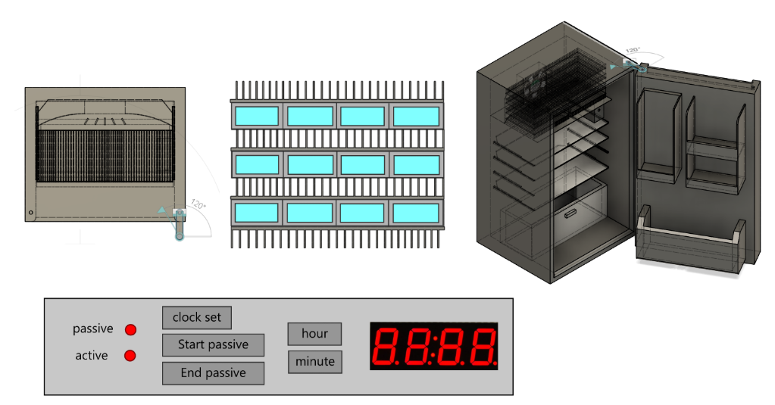
Figure 1 - Smart Refrigerator final design including freezer compartment layout, fin and ice block assembly, retrofitted mini refrigerator, and control panel layout

Our smart refrigerator will be programmed to maintain an internal temperature of 37 degrees Fahrenheit. We determined that the control panel should be placed on the top inside lip of the fridge, as this is what is most common. We will also be using LED lights for the control panel to indicate whether our project is on its active or passive cycle. The user will also be able to configure when they want the passive cycle to start and end with time setting adjustment buttons which work similarly to an alarm clock. There will also be LED lights that indicate whether it is on its active or passive cycle. Our control panel design layout is shown in the bottom image of Figure 1.
For the fin and ice configuration, our group decided on the design in the image in the middle. There will be four layers of fins to enhance heat transfer, along with three layers of ice to maintain the surface temperature at 0 degrees Celsius. For the ice containers, we will be using aluminum rectangular tubing with four individual tubes for each of the three thermal mass layers.
Since we will be using the freezer section for our thermal mass and passive cycle, we decided to direct airflow with a fan through the middle of the top back panel of the freezer to maximize convection. To further direct and smooth the air flow, we will also be using five vanes and curved sheet metal at the fan opening. This layout is shown in the top left corner of Figure 1.
Project Budget and complete rationale
Table 1 - Bill of Materials
Component Name | MFG# | Description/ Purpose | Quantity | Cost/ Unit | Shipping | Total | Notes | Link
Fan | SP100A | 4.68 Inch AC Tube Axial | 1 | 13.95 | $ 9.18 | $ 23.13 | Meets CFM requirement | Link
R134a Recharge kit | B09S69H5DP | To pressurize and add pipe length | 1 | 20.99 | $ - | $ 20.99 | Will need can of R-134a | Link
R-134A | SER134A | Pure R-134A | 1 | 14.00 | $ 11.32 | $ 25.32 |  | Link
Copper Pipe | 630456606893 | Refrigerant Piping 3/8" OD | 1 | 16.99 | $ - | $ 16.99 | 5 Feet of tubing | Link
Heatsink | 64AS | 7.874'' (200mm) Wide Heatsink (64AS) | 8 | 9.90 | $ 12.36 | $ 91.56 | 7.9" x 6" | Link
Temperature Sensor | ERP 2188820 | Refrigerator Thermistor | 2 | 11.00 | $ - | $ 22.00 |  | Link
Display | TM1637 | 4 Digit 7 Segment Display | 1 | 3.95 | $ 4.09 | $ 8.04 |  | Link
Buttons | EK1019 | 6x6x4.3mm TACT Switch Push Button | 1 | 6.98 | $ - | $ 6.98 | (pack of 50) Purchasing separately | link
Aluminum Tube | T34118 | Ice casings | 12 | 9.30 | $ 41.00 | $ 152.60 | 4x1x1/8"x6  Note this shipping rate covers both the tube and sheets | Link
Sheet Aluminum | S3063 | Ice Casings/ controlling airflow | 2 | 42.72 |  | $ 85.44 | 24"x24"x1/16" | link
Microcontroller | ESP32 | Control the Fridge | 1 | 8.00 | $ - | $ 8.00 | Already owned | link

Total including already purchased buttons and microcontroller: $461.05
Total funding requested from the department: $446.07

Part justifications

Heat sink selection
After comparing calculations with and without a heat sink, we determined that a heat sink is required to provide adequate heat transfer between the ice block and the air passing through the freezer compartment. There were many factors involved in choosing the optimal heat sink, including the size restrictions of the small freezer compartment we were working with, the length vs width orientation of the heat sink, as well as the minimum airflow to achieve the desired heat transfer. To determine the required heat transfer to maintain refrigeration temperature, we calculated the heat transfer through the walls of the refrigerator in addition to the added groceries that were stimulated by the energy required to take cans of water from room temperature to refrigeration temperature. The load profile can be found below in Figure 2.

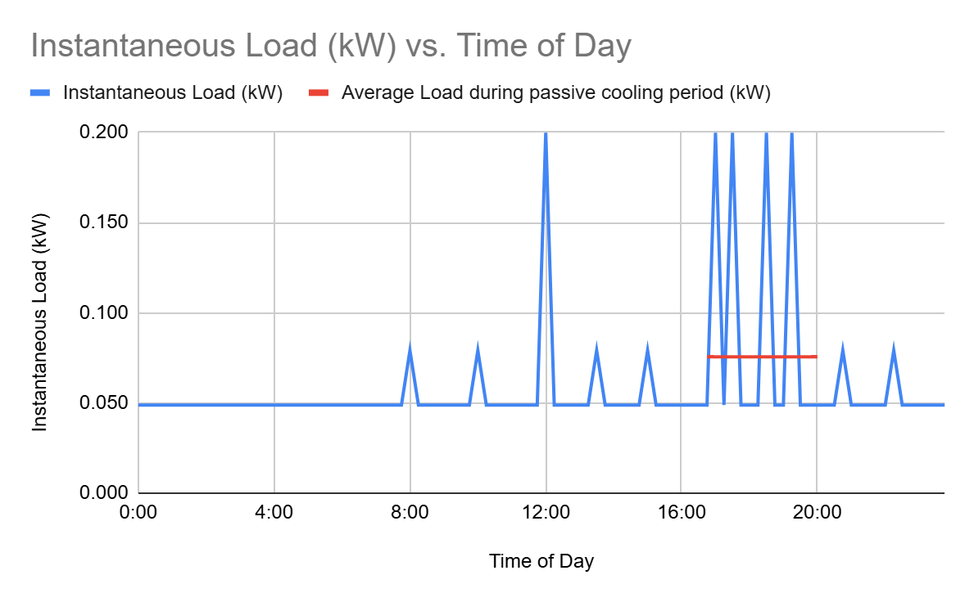
Figure 2 - Simulated instantaneous load on refrigerator cooling system

To choose the heat sink, we first created a tool in Google Sheets that used input dimensions of the heat sink and ice block, then calculated the resulting heat transfer given an input air flow rate. An example of the output calculations is shown below in Table 2. If the provided heat transfer rate was greater than the required heat transfer rate to maintain refrigeration temperature, the airflow was considered acceptable, as demonstrated by the green-filled cells in Table 2.

Table 2- Heat transfer calculations for heat sink
volumetric flow (CFM) | 20 | 30 | 50 | 55 | 60 | 70
V_dot_{Total} (m^3/s) | 0.00944 | 0.01416 | 0.02360 | 0.02596 | 0.02832 | 0.03304
Mdot _{Total} (kg/s) | 0.01215 | 0.01822 | 0.03037 | 0.03340 | 0.03644 | 0.04251
V_dot_{Per fin} (m^3/s) | 0.0000433 | 0.0000650 | 0.0001083 | 0.0001191 | 0.0001299 | 0.0001516
Mdot_{Per fin} (kg/s) | 0.000056 | 0.000084 | 0.000139 | 0.000153 | 0.000167 | 0.000195
V_{air} (m/s) | 0.408 | 0.612 | 1.020 | 1.122 | 1.224 | 1.427
Re | 295 | 442 | 737 | 811 | 885 | 1032
Flow | L | L | L | L | L | L
Entry Length | 0.156 | 0.233 | 0.389 | 0.428 | 0.467 | 0.545
Developed? | N | N | N | N | N | N
Nu | 4.42 | 4.74 | 5.30 | 5.43 | 5.55 | 5.79
h (W/m^2C) | 10.30 | 11.04 | 12.34 | 12.64 | 12.93 | 13.49
m | 4.06 | 4.20 | 4.44 | 4.50 | 4.55 | 4.64
fin efficiency | 88.94% | 88.26% | 87.08% | 86.82% | 86.57% | 86.08%
T_{outlet} (C) | 1.2 | 1.6 | 2.1 | 2.1 | 2.2 | 2.3
(Tbase-Tin) | 5.04 | 5.04 | 5.04 | 5.04 | 5.04 | 5.04
(Tout - Tsurf) | 1.1 | 1.5 | 2.0 | 2.1 | 2.2 | 2.3
Delta T LMTD | 2.6 | 3.0 | 3.3 | 3.4 | 3.4 | 3.5
Qfin, actual (W) | 31.9 | 38.5 | 47.4 | 49.2 | 50.8 | 53.9
Qdot diff | -18.60 | -12.02 | -3.11 | -1.33 | 0.33 | 3.38

The ultimate goal of this optimization process was to determine which heat sink had the best fin height, thickness, and spacing and how many layers of ice and fins were necessary to achieve a reasonable airflow rate. We chose the heat sink that had the optimal heat transfer when compared to six different heat sinks that varied in fin spacing and height. Next, we determined that three layers of ice were required with the chosen heat sink to obtain a reasonable average airflow rate of approximately 60 CFM.

Fan Selection
Before selecting our fan, we calculated the pressure drop at various air flow rates to create a system curve shown below in Figure 3. Then, we researched fans that had a maximum airflow rate that was about twice as large as our calculated average airflow. This would allow the passive system to respond to larger instantaneous loads and prevent the refrigerated space from exceeding the acceptable temperature range. We considered the fans' power consumption and size as these were the most important considerations. After choosing the fan that best met these criteria, we plotted the provided fan curve against our system curve to ensure that the fan was able to overcome the pressure drop it would encounter. Since the fan curve intersects the fan curve at a greater airflow than the minimum average airflow we calculated previously, we know that the fan will be adequate. We will modulate the fan to lower or higher speeds to meet the instantaneous airflow requirements.

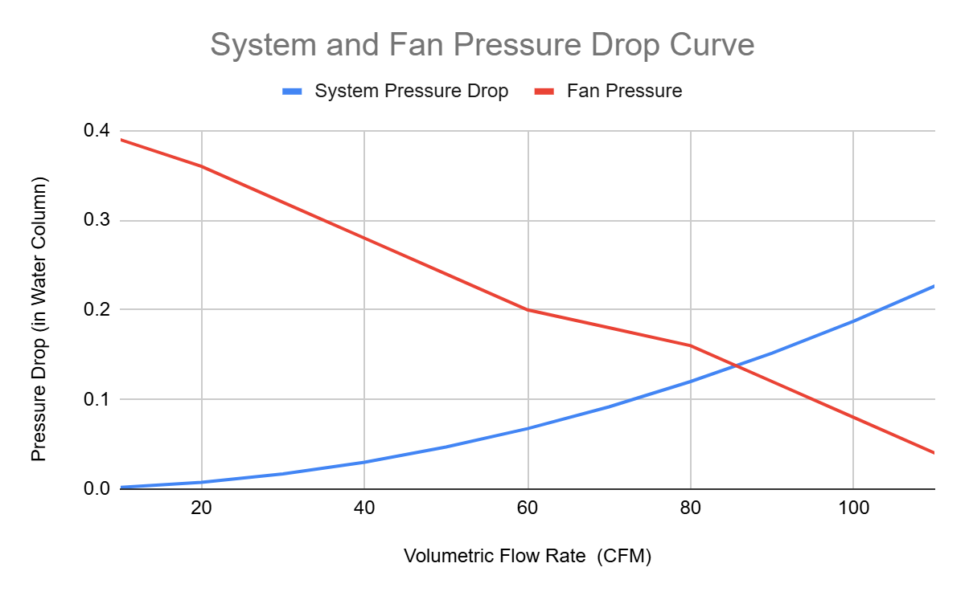
Figure 3 - System and Fan Pressure Curve

Ice Block Containers
We chose hollow aluminum tubes for our ice block containers instead of bending aluminum sheet metal for ease of fabrication and less potential for water leakage. By using tubing, we can create module ice cases by cutting the tube to the desired length, filling it with water, then welding an aluminum plate end cap on each end. We will utilize the aluminum plate for the end caps, as well as fashioning brackets to connect the fin/casing housings together in the freezer portion of our fridge. The last usages of our aluminum plate will be to create a return duct on the back wall of the inside of our mini refrigerator to return air to the fan to be cooled off during the passive cycle, as well as vanes and a wall to along the backside of the evaporator coils to direct airflow over the ice block casing assembly.

Electronic components
We decided to use the ESP32 microcontroller because of its vast capabilities and versatility. This microcontroller can be used as an efficient central processing unit capable of managing system inputs and outputs, sensors, and wireless communication. It is also a relatively fast processor with a speed of 240 MHz, which is more than sufficient for the system we’re planning to run. Additionally, it’s compatible with Arduino and MicroPython, the software that we’ve familiarized ourselves with in previous courses.
We chose the temperature sensors to be thermistors because of their high sensitivity to changes in temperature and their lower costs than alternative devices like thermocouples. Then we need a 7-segment display for our control panel that will display the time that the user selects for the start and stop of the passive cycle.

Return air ducting, fan ducting
To ensure that the air travels through all of the shelves rather than immediately re-entering the freezer compartment, we are installing a thin aluminum sheet to act as a return duct with a gap at the bottom of the refrigeration compartment. This requires a sheet of aluminum that will act as the return duct.
Within the freezer compartment itself, the air flow from the fan must be contained such that it flows through the fin + ice block assembly. To do this, we will be using aluminum sheets that are bent to fit into the corners of the freezer compartment. Furthermore, vanes will be used to disperse the fan flow to more equally distribute the flow through the individual fins. These vanes can be cut from the thin aluminum sheet as well.

Refrigerant piping
The freezer space in the mini refrigerator we are retrofitting only has a height of about 5 inches. However, the fin and ice block assembly has a height of 6.15 inches. In order for the fin and ice block assembly to fit, we must detach the evaporator coil and move it about 1.4 inches lower. We need a few inches of piping to account for this vertical translation. We chose the shortest amount of piping possible to save money; alas, the shortest length available was a 5-foot coil. In addition to this, because we are cutting the preexisting refrigerant piping, we need a way to pressurize and add more refrigerant after we drain it. We will be purchasing a kit that adds valves to hook up to a hose so that we can add refrigerant. This kit also comes with a pressure gauge, which will be very helpful so that we can ensure the compressor is operating smoothly. Lastly, we will be purchasing refrigerant to recharge the refrigerant line. Our mini-fridge requires 2.3 oz of R-134A, so we budgeted for a 12-oz. can.

Detailed Part List

The following is a list of the remaining parts that must be purchased for our project. Note that the microcontroller and buttons have already been purchased/owned by team members and do not need to be purchased by the department.

- Aluminum Rectangle Tube
  - Link
  - Model: 4”x1”x1/8”
  - Stock Number: T34118
  - Dimensions: 4”x1” (1/ 8” thick) Choose cut to size, enter 6” Lengths
  - Quantity: 12 Pieces
- Aluminum Sheet
  - Link
  - Stock Number: S3063
  - Dimensions: 2x2 Feet (1/16” thick)
  - Quantity: 2
- Aluminum heatsink
  - Link
  - Model: 7.874'' (200mm) Wide Heatsink (64AS)
  - Dimensions: Choose 6” length
  - Quantity: 8
- Refrigeration Piping Kit
  - Link
  - Model: B09S69H5DP
  - Dimensions: n/a
  - Quantity: 1
- Can of R-134A
  - Link
  - Model: SER134A
  - Dimensions: n/a
  - Quantity: 1
- Temperature Sensor
  - Link
  - Model: ERP 2188820
  - Dimensions: n/a
  - Quantity: 2
- Seven Segment Display
  - Link
  - Model: TM1637
  - Dimensions: n/a
  - Quantity: 1
- Fan
  - Link
  - Model: Sunon SP100A-1123XBT.GN
  - Dimensions: 4.68 x 4.68 in
  - Quantity: 1

